

(Note: Certificates available in House and Senate Office Supply Store)
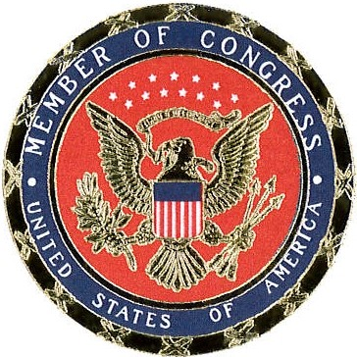







upon your receipt of the
Gold Award
of the Girl Scouts of the United States of America.

DATE MEMBER OF CONGRESS

